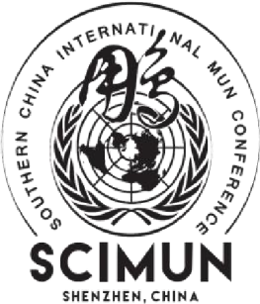 **SOUTHERN CHINA** 1177 Wanghai Rd,

Nanshan, Shenzhen,

**INTERNATIONAL MODEL** Guangdong, China

**UNITED NATIONS 2026**

scimun2026@outlook.com **Nellie Chen**

***Secretary General***June 18th, 2025

Dear Esteemed Advisor and Student Leader,

I am honored to invite you and your institution to our eleventh annual Southern China International Model United Nations (SCIMUN) conference. This year, our conference will be held in March 26-28th, 2026 at the Shekou Hilton in Shenzhen, China.

SCIMUN was started in 2016 by student Mark Shen and advisor Kyle Mims under the motto student-led, student-initiated, and student-involved, which we embody to this day. As SCIMUN has evolved, our pursuit to create a positive atmosphere that encourages creativity, collaboration, and passion has not only persisted but also grown. Therefore, we promise that this year’s conference will proceed to foster professionalism, sustainability, global connection, cooperation, leadership, and development.

During the three days, each student will be assigned to represent a country in their respective United Nations committee. These country representatives, otherwise known as delegates, will engage in discussions and debates to collaboratively develop solutions to urgent global issues. On an individual scale, SCIMUN XI will serve as a valuable opportunity for participants to improve debate, public speaking, research, and analytic skills, and even provide practical workplace experience. Most importantly, it will enhance their eligibility as a global citizen and elevate awareness on international relations.

This year, SCIMUN 2026 has chosen the theme **"Motions in Mind"**, reaffirming the core vision of the conference. SCIMUN XI is not solely a forum for discussing international affairs and understanding global challenges, but also an opportunity to broaden perspectives and ignite empathy – driving our words into meaningful action. The conference will foster meaningful interaction and collaboration, where exemplary leadership can emerge through negotiation and mediation.

This year, SCIMUN presents 5 committees: Security Council, United Nations Development Program, World Health Organization, United Nations Commission on Science and Technology for Development, and Human Rights Council. Each committee varies in difficulty

To attend the conference, please fill out the registration form attached to this email or visit our official SCIMUN website [www.scimun.net to](http://www.scimun.net/) fill out the ‘School Registration’ form posted on the ‘Registration’ section. Should there be any inquiries, feel free to contact us at scimun2026@outlook.com or at our official WeChat account ‘SCIMUN’.

Once again, it is my honor to invite you all to SCIMUN 2026. I hope to see you all at our conference in March.

Sincerely,

Nellie Chen

Secretary General

Southern China International Model United Nations XI