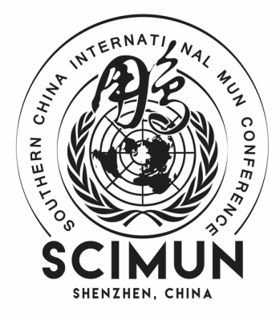
SCIMUN 2024
SCIMUN IX SCHOOL Registration Form

Thank you for your interest in our conference. Please fill out the following document as accurately as possible. The completed form is due to scimun2022@outlook.com by November 25th, 2023. The earlier the submission, the more we will appreciate it. If there are any questions, please feel free to email us!

Payment Details:
The payment per delegate is 1550 RMB.
If the student wants to stay at a hotel during the conference days, they will be charged an extra accommodation fee of 550 RMB.
Advisors will be charged separately. Advisors who don’t need to stay at a hotel for the three-day conference will be 200 RMB each. If the advisors will stay at a hotel, it will be an additional 1100 RMB each.

***It is important to note that our conference fee does not cover catering and transportation to and from the event. However, snacks and drinks will be provided throughout the conference***

*If you withdraw from the conference after January 6th, 2024, we will not refund unless it is due to COVID restrictions or other serious causes.

*If you are planning to stay at a hotel, please provide passport number (or other method of identification) for each delegate at the end of the document.

School Name:
Number of Delegates:

 | Full Name | Gender | Grade (5-12) | Nationality | Preferred Committee

Delegate 1

Delegate 2

Delegate 3

Delegate 4

Delegate 5

Delegate 6

Delegate 7

Delegate 8

Delegate 9
(please feel free to add cells if needed)

Passport #:

